Conditional Expression and Procedures: CASE Condition which is similar to if else statement.

In below query we are allotting our customers a class such as Premium, Plus and Normal based on given condition.

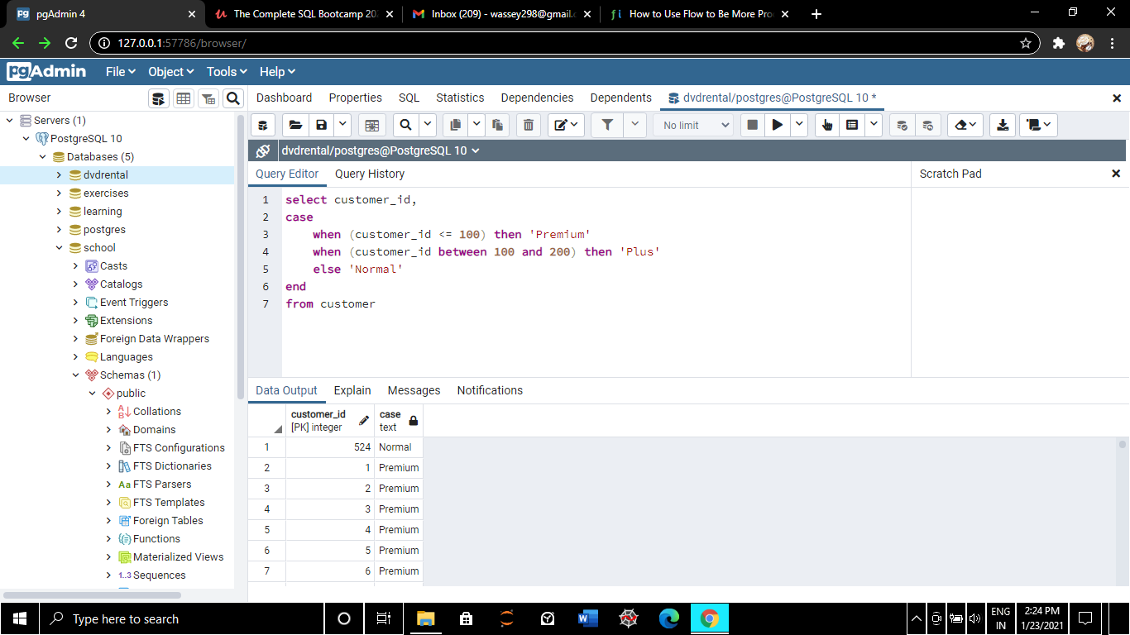

Here we are changing case to ‘customer_class’ which can be seen in data output

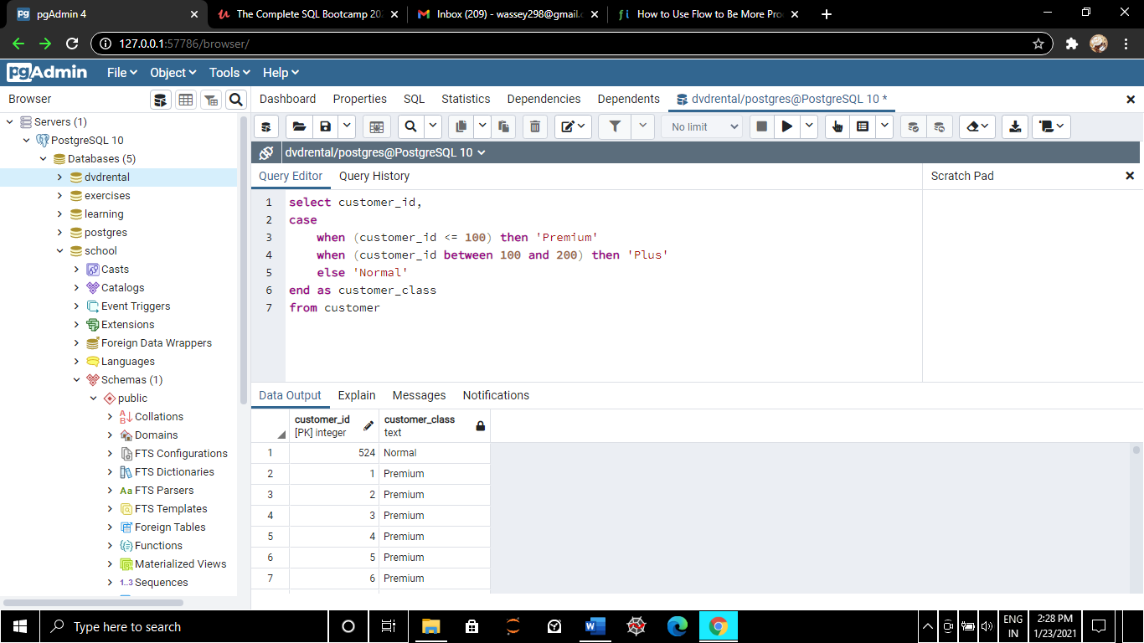

Imagine we are running a raffle where we have mentioned customer_id once and check for equality

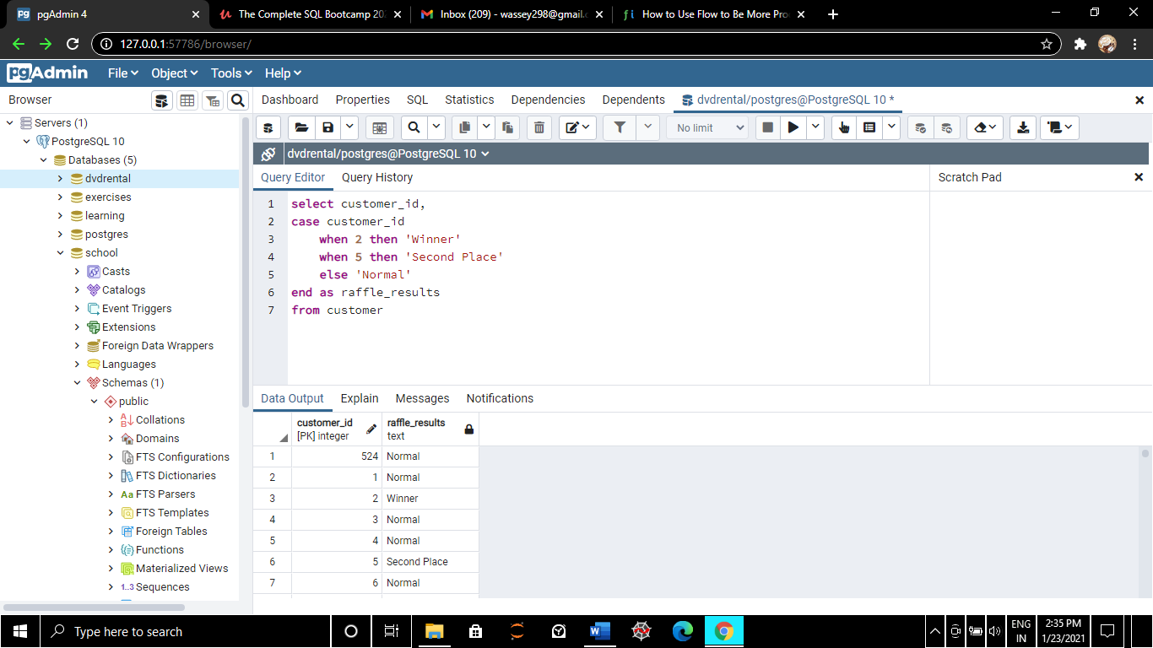

Here we are querying to know how many movies of rental rate 0.99 we have, but firstly we change it to 1 by using CASE keyword then by using SUM keyword we know how many of them we have.

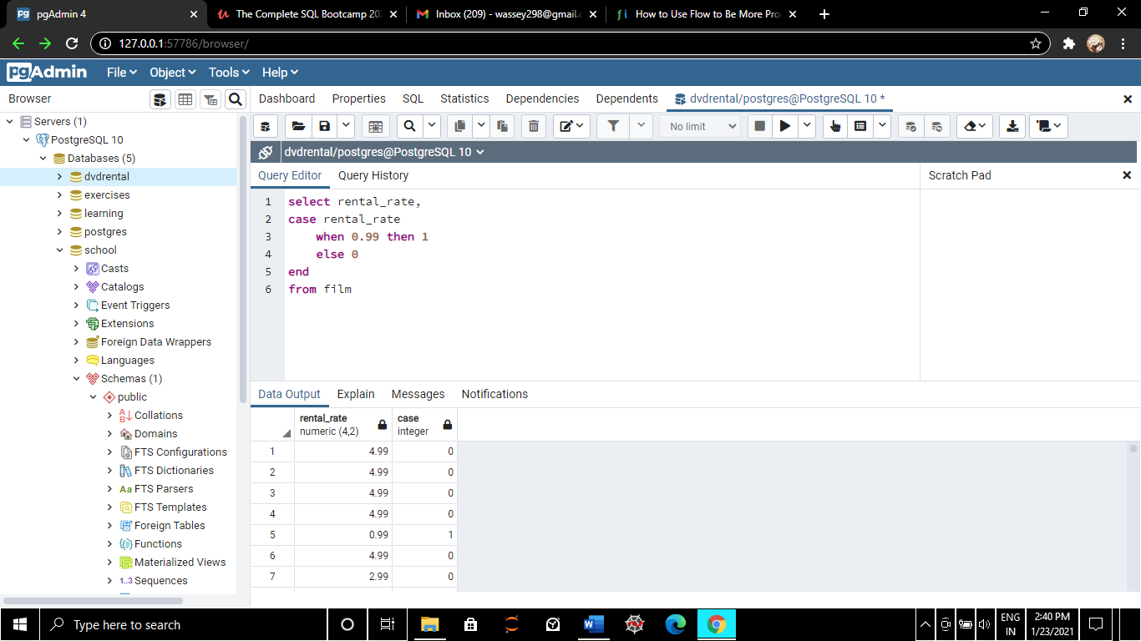

Using SUM condition

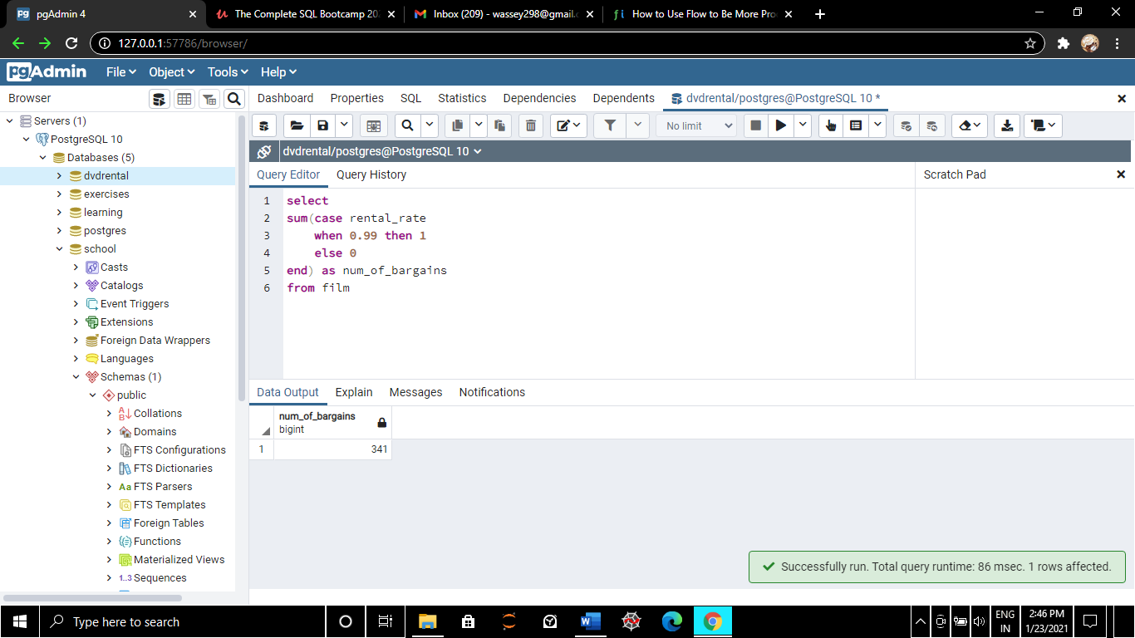

Here we are comparing other prices of rental rate

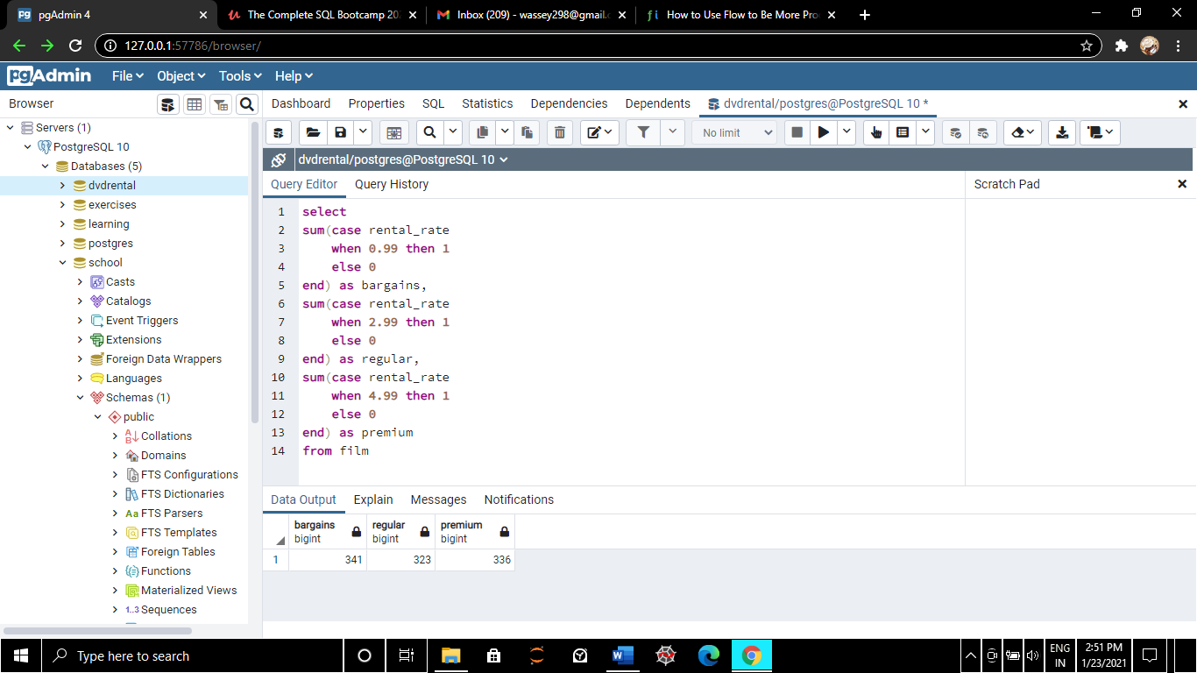

Here we want to know and compare the various amounts of films we have per movie rating?

